- Screen: Nurse Superintendent
Nurse superintendent currently lands on the duty management page as below and it is the only page that is there when a user logs in as nurse superintendent
Corrections to be made: Nurse Superintendent screen should be able to see all the IPD wards and patient details.
Also – there is no sidebar for the nurse superintendent screen along with the logout button as well
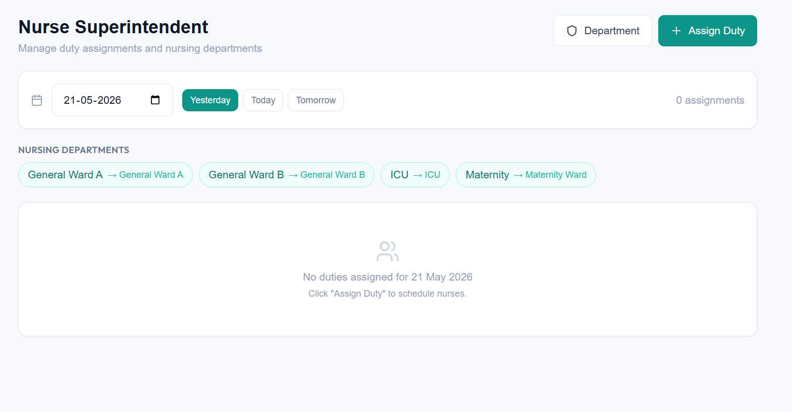
- Screen: Nurse
- Nurse Screen lands on to Nurse Dashboard page but it does not have any sidebar – the sidebar should be there in this page as well.
- A Nurse should not be able to see the “Bill summary section” in the Patient overview page (refer below screenshot). Please note only the bill summary section should not be visible – the overview section should be there. The nurse should not also be able to see “Payments” tab in the below page
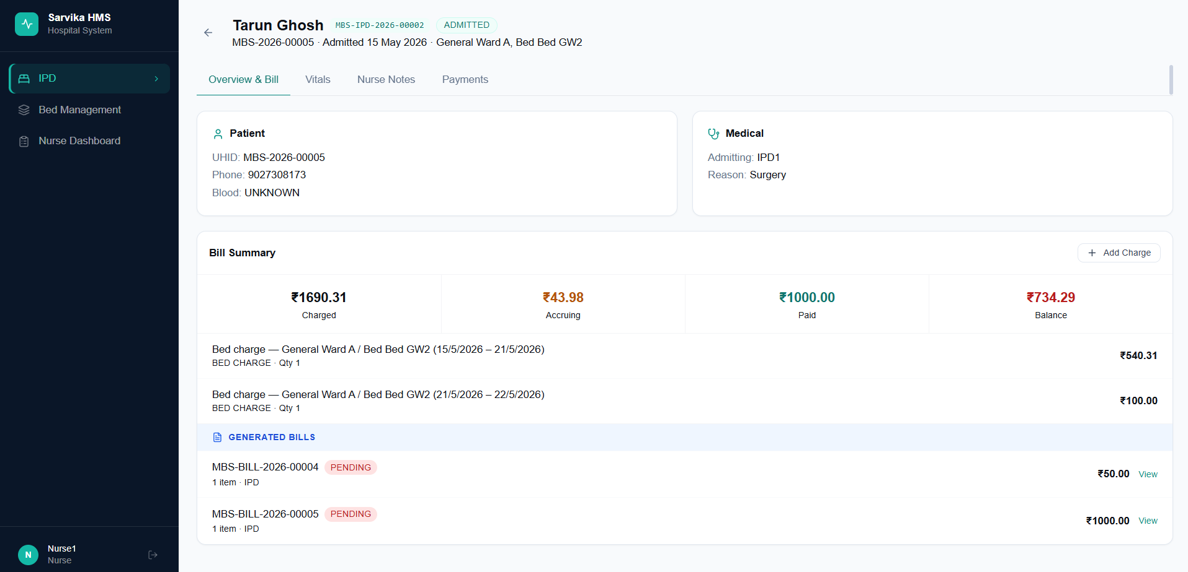
- In the overview section the prescription of the patient should be shown along with medicines prescribed and other details like which doctor has visited and everything
- Upon clicking on “Add Charge” button – the nurse should only be able to add the item name and should not see the “Price” or “Bill” (although the bill and the price for the item would get added as it is but only the nurse won’t be able to see any price/bill). And in the this add charge page also – it should be type+dropdown for all the bill types (consumables/medicines etc) except for “Procedure” and “Other” bill type which should be free text only
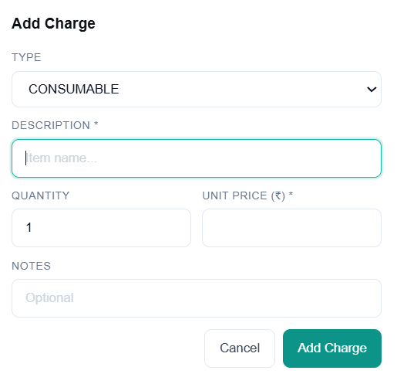
- Vitals and Nurse notes can be a single tab instead of 2 separate tabs
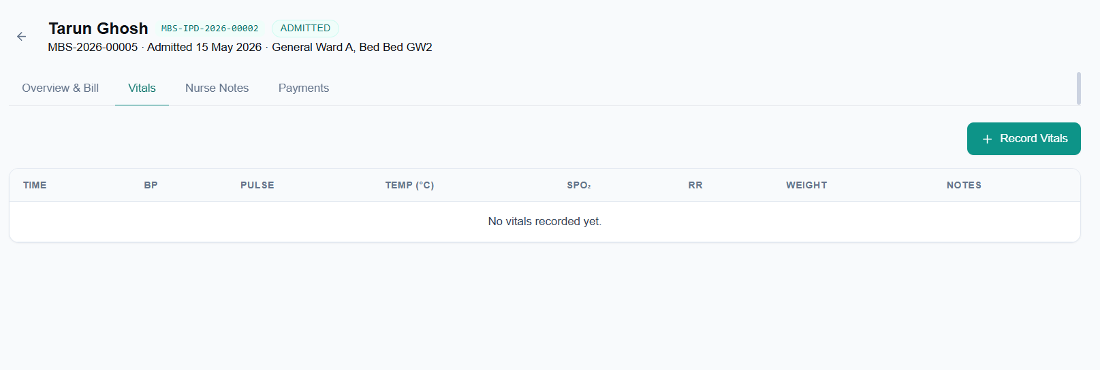
- Nurse should not be able to see “Bed Management” and “IPD” page – only the nurse dashboard which will be showing the details of patient in the ward against which the nurse’s duty is assigned for that day
